number=input("Enter a number")

for e in number:

if int(e) % 3 == 0:

print("Fizz")

elif int(e) % 5 == 0:

print("Buzz")

elif (int(e)%3) and (int(e)%5):

print("FizzBuzz")

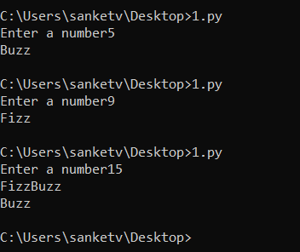

\*\*\*\*\*\*\*\*\*\*\*\*\*\*\*\*\*\*\*\*\*\*\*\*\*\*\*\*\*\*\*\*\*\*\*\*\*\*\*\*\*\*\*\*\*\*\*\*\*\*\*\*\*\*\*\*\*\*\*\*\*\*\*\*\*\*\*\*\*\*\*\*\*\*\*\*\*\*\*\*\*\*

bal=0

while('true'):

ch = input ('''Enter d or D for Deposit

Enter w or W to Withdraw

Enter x to exit''')

if (ch=='d' or ch == 'D'):

amt = int (input ('Enter amount: '))

bal += amt

elif (ch=='w' or ch == 'W'):

amt = int (input ('Enter amount: '))

bal-= amt

else:

print (bal)

break

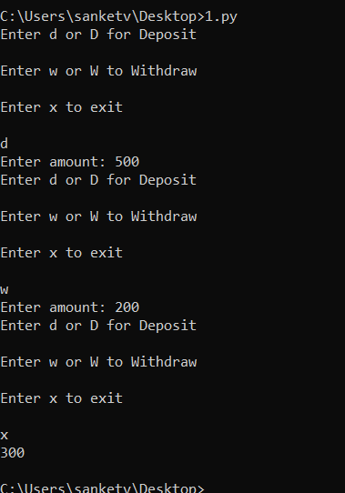

call = int(input("Enter your number of calls for this month: "))

if call <= 100:

bill = 200

elif 100 < call <= 150:

addon = call - 100

bill = 200 + 0.60 \* addon

elif 150 < call <= 200:

addon = call - 150

bill = 200 + 0.60 \* 50 + 0.50 \* addon

else:

addon = call - 200

bill = 200 + 0.60 \* 50 + 0.50 \* 50 + 0.40 \* addon

print("Total bill For this month is Rs", bill)

